**Microsoft Copilot: Image analysis**

**Name: Vidhi Khandelwal**

**GWID: G30891152**

Microsoft's GPT-4 has transformed AI by expanding its capabilities beyond text generation to include image analysis. Unlike its previous versions, which focused on producing human-like text, GPT-4 can now interpret and analyse images with remarkable accuracy. This advancement enables GPT-4 to describe images, detect objects, and generate detailed insights by combining language understanding and visual processing. This blog explores the copilot’s remarkable capabilities in image analysis, as well as its potential applications.

**Skyscraper:**

The first thing I wanted to test with GPT-4 was if it’s can detect the most famous places in the world accurately. Below is the description Copilot gave me:

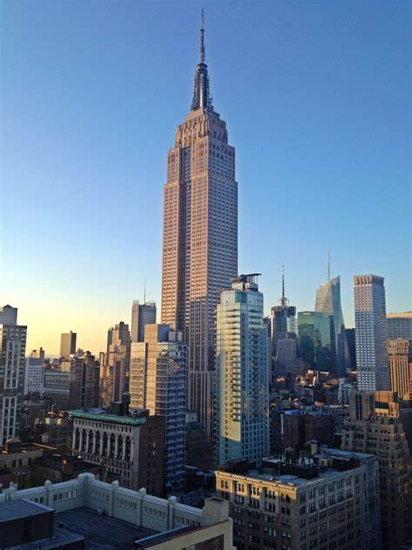

**Empire State Building**

The image shows a stunning view of New York City with the Empire State Building as the focal point. This iconic skyscraper, known for its Art Deco architecture and towering spire, stands prominently against a clear, blue sky. The photo appears to be taken in the late afternoon, as indicated by the warm lighting and long shadows cast by the surrounding buildings. The Empire State Building’s height and distinctive design make it a standout feature in the urban landscape, symbolizing the architectural achievements of early 20th-century America.

The generated text describes the Empire State Building’s features with its architectural design and timeline of when the picture was taken.

**City view:**

This picture was taken during summer when I went to see the city view from the top of the Washington Monument. The picture is a bit ambiguous as there is no description but here’s the response I got from the copilot when I asked to describe the picture:

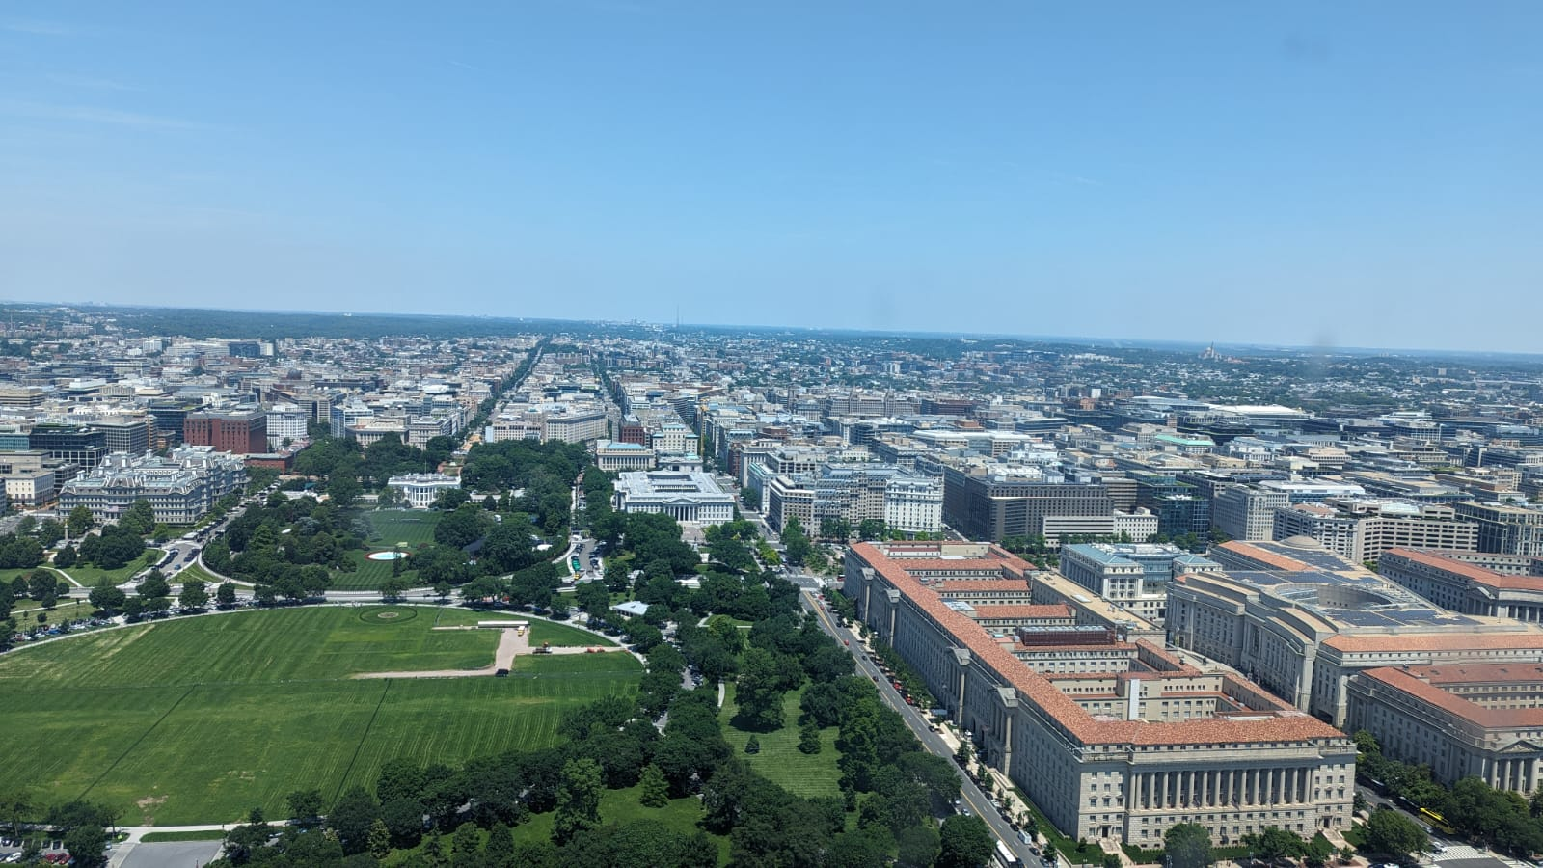

**City view from the top of the Washington Monument**

The image is an aerial view of Washington, D.C., focusing on the National Mall area. Here are the detailed observations:

**Foreground**: The large green space in the foreground is the National Mall. This area is known for its open lawns, walking paths, and significant monuments.

**Central Monument**: At the centre of the green space, you can see the Washington Monument, a tall, slender obelisk that stands out prominently. This monument is one of the most iconic landmarks in the United States.

**Surrounding Buildings**: The buildings surrounding the National Mall are mostly uniform in height and design, suggesting they are governmental or institutional structures. These include museums, government offices, and other important buildings.

**Street Layout**: The streets are laid out in a clear grid pattern, extending in straight lines from the central green space towards the horizon. This layout emphasizes the planned and orderly nature of the city.

**Sky and Weather**: The sky is blue and mostly clear, with only a few scattered clouds, indicating good weather conditions.

Further, I asked at what time the picture was taken here’s what I got:

The image appears to have been taken during the daytime, likely in the late morning or early afternoon. This is suggested by the clear visibility, the even lighting, and the absence of long shadows, which typically occur during early morning or late afternoon. The bright and well-lit environment indicates that the sun is relatively high in the sky. feature in the urban landscape, symbolizing the architectural achievements of early 20th-century America.

Copilot was successful in analyzing the picture in detail with all the necessary descriptions about the surrounding buildings, monument, and street layouts.

**Library:**

The last picture is my absolute favourite and the most beautiful library I have seen. When I asked copilot about the image here’s what I got:

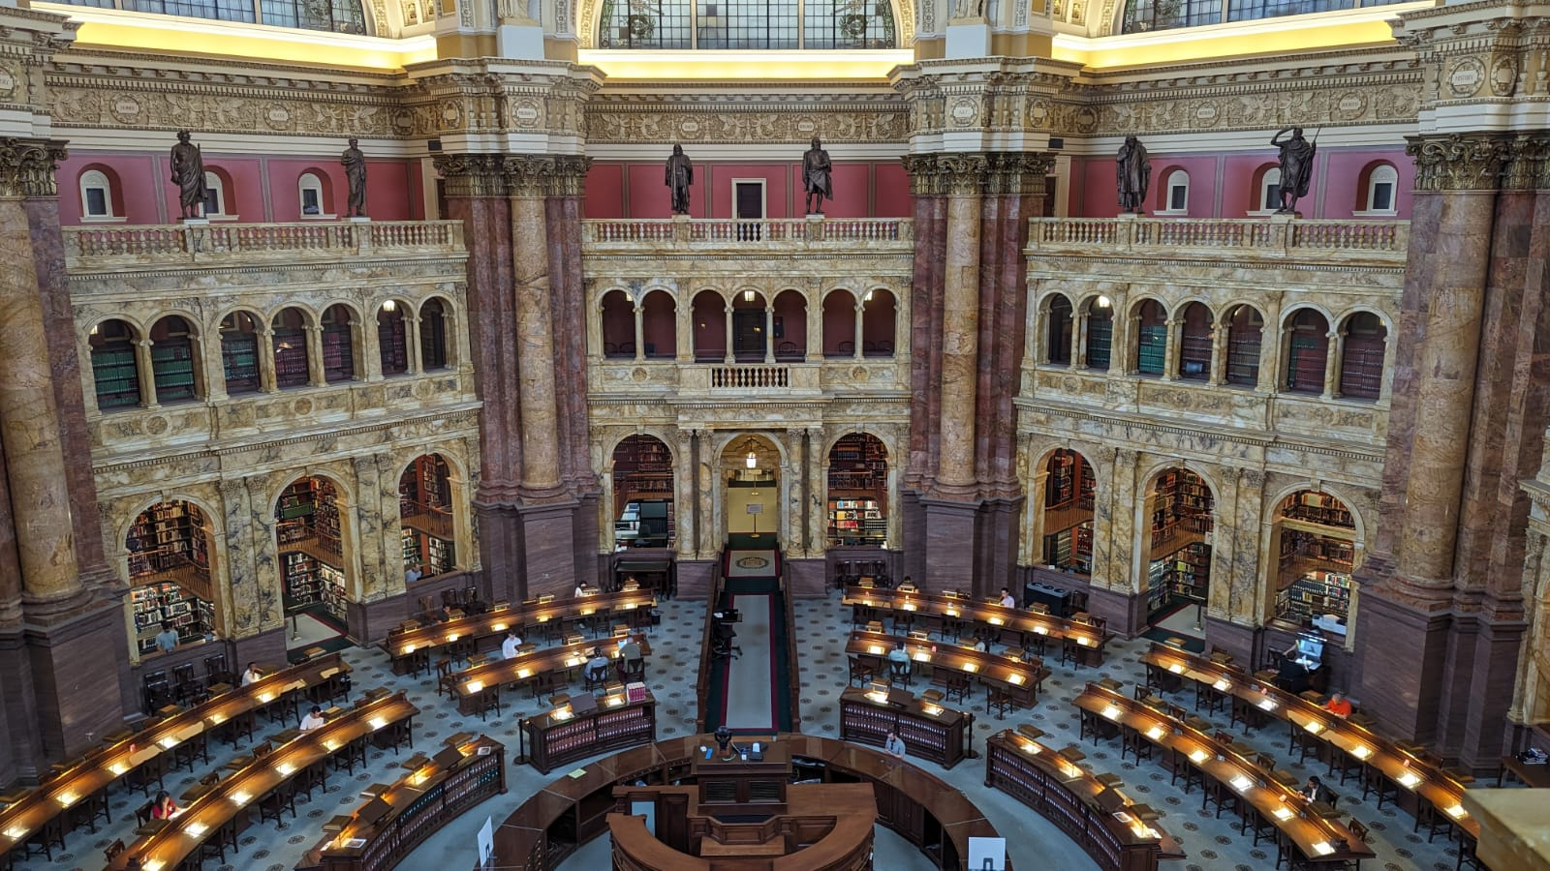

The image depicts the interior of a library or reading room. Here are the detailed contents:

**Library of Congress**

**Architecture**: The room features an ornate, high ceiling with intricate designs and a central dome. The walls are lined with multiple levels of arched openings, some containing statues.

**Reading Tables**: The lower level has rows of reading tables equipped with lamps. These tables are arranged in a semi-circular pattern around a central area.

**Central Area**: The central area appears to be an information desk or circulation area, serving as the focal point of the room.

**Lighting**: The room is well-lit, with natural light likely coming from windows or skylights, in addition to the lamps on the reading tables.

**Statues and Decorations**: The arched openings on the walls contain statues, adding to the historical and formal atmosphere of the space.

The overall setting suggests that this is a significant and possibly historical library, designed for academic or public use due to its scale and formality.

Furthermore, I asked what is the city of this library:

The library in the image is the **Library of Congress**, located in **Washington, D.C., United States**. This grand reading room is part of the Thomas Jefferson Building, which is known for its stunning architecture and historical significance.

The copilot was able to describe the library with every small detail including the name and location of the library.